import json
import re
from collections import defaultdict

import inflector
import numpy as np
import pandas as pd
import tensorflow as tf
import tensorflow_hub as hub
from nltk import RegexpTokenizer
from sklearn import svm
from sklearn.metrics import classification_report
from sklearn.model_selection import cross_val_score, train_test_split
from stanfordcorenlp import StanfordCoreNLP

regex = RegexpTokenizer(r"\b\w+\b");

def buildStopWords():
fileInput = open(r"D:\lucru\Licenta Valencia based\Git repo\A-Semi-supervised-Method-to-Classify-Educational-Videos\helper_data\stop_words_english.txt", r'r', encoding='latin-1')
for word in fileInput:
word = word.replace("\n", "")
english_stopwords.append(word)

english_stopwords = []
buildStopWords()
singularizator = inflector.English()

nlp = StanfordCoreNLP("http://localhost", port=8000)

def ifIsFromStopWords(word):
if word in english_stopwords:
return True
return False

def clean_text(text):
''' Lowering text and removing undesirable marks

Parameter:

text: document to be cleaned
'''

text = text.lower()
text = re.sub(r'[^\w\s]','',text)
text = re.sub("(\s\d+)","",text)
text = ' '.join( [w for w in text.split() if len(w)>3] )
text = re.sub('\s+', ' ', text) # matches all whitespace characters
text = text.strip(' ')
return text

def preprocess(text):
result = ""
text = clean_text(text)
if len(text) > 3:
for word, pos in nlp.pos_tag(text):
if( ifIsFromStopWords(word) == False ): #sa nu fie in lista de stopwords
result += singularizator.singularize(word) + " " #punem la forma de singular
return result

def processTranscript(transcript):
transcript = preprocess(transcript)
words = regex.tokenize(transcript)
processedTranscript = ""
for word in words:
word = word.lower()
processedTranscript = processedTranscript + word + " "
return processedTranscript

# collecting wiki data
dataframe = pd.read_excel(r"D:\lucru\Licenta Valencia based\Git repo\A-Semi-supervised-Method-to-Classify-Educational-Videos\data_sets\EnglishWikipediaDataSet-V1.xlsx", usecols = [1])

articles = dataframe.values

dataframe = pd.read_excel(r"D:\lucru\Licenta Valencia based\Git repo\A-Semi-supervised-Method-to-Classify-Educational-Videos\data_sets\EnglishWikipediaDataSet-V1.xlsx", usecols = [2])

labels = dataframe.values

processedArticles = []
processedLabels = []

for i in range(0,len(articles)):
art = articles[i][0]

art = str(art)

if len(art) < 50:
continue

processedArticles.append(processTranscript(art))

processedLabels.append(labels[i])

wikiTrain, wikiEvalTrain, wikiTrainTest, wikiEvalTest = train_test_split(processedArticles,processedLabels , test_size=0.30, random_state=42)

wikiEvalTrain, wikiFinalTrain, wikiEvalTest, wikiFinalTest = train_test_split(wikiEvalTrain,wikiEvalTest , test_size=0.50, random_state=42)

print("Loading Transcripts")

# collecting ted data
dataframe = pd.read_csv(r"D:\lucru\Licenta Valencia based\Git repo\A-Semi-supervised-Method-to-Classify-Educational-Videos\original_dataset\ted_main.csv", usecols = ["tags"])
tags_ted = dataframe.values

dataframe = pd.read_csv(r"D:\lucru\Licenta Valencia based\Git repo\A-Semi-supervised-Method-to-Classify-Educational-Videos\original_dataset\ted_main.csv", usecols = ["title"])
titles_ted = dataframe.values

dataframe = pd.read_csv(r"D:\lucru\Licenta Valencia based\Git repo\A-Semi-supervised-Method-to-Classify-Educational-Videos\original_dataset\ted_main.csv", usecols = ["description"])
descriptions_ted = dataframe.values

dataframe = pd.read_csv(r"D:\lucru\Licenta Valencia based\Git repo\A-Semi-supervised-Method-to-Classify-Educational-Videos\original_dataset\ted_main.csv", usecols = ["url"])
urls_ted = dataframe.values

# dictUrlTags is a dictionary of url string and the list with tags
dictUrlTags = {}

for i in range(0, len(urls_ted)):
listTags = re.findall(r'\w+', tags_ted[i][0])
dictUrlTags[str(urls_ted[i][0])] = listTags

# dictUrlTitle is a dictionary of url string and the list with words from title
dictUrlTitle = {}
for i in range(0, len(urls_ted)):
listTitle = re.findall(r'\w+', titles_ted[i][0])
dictUrlTitle[str(urls_ted[i][0])] = listTitle

# dictUrlDescription is a dictionary of url string and the list with words from description
dictUrlDescription = {}
for i in range(0, len(urls_ted)):
listDescription = re.findall(r'\w+', descriptions_ted[i][0])
dictUrlDescription[str(urls_ted[i][0])] = listDescription

with open(r'D:\lucru\Licenta Valencia based\Git repo\A-Semi-supervised-Method-to-Classify-Educational-Videos\original_dataset\transcripts.json',"r", encoding='utf-8') as f:
videos_json = json.load(f)

dictUrlTranscript = {}

for video in videos_json:
url = video["url"]
transcript = video["transcript"]
dictUrlTranscript[url] = transcript

# dictUrlTranscript is a dictionary of url string and the transcript

transcripts = []
transcriptsKeywords = []
regex = RegexpTokenizer(r"\b\w+\b");

dictIndexTranscript = {}
index = 0
for item in videos_json:
url = item["url"]

if(url not in dictUrlTags):
continue
if(url not in dictUrlTranscript):
continue

keywords_obj = dictUrlTags[url]
keywords = ""

if(type(keywords_obj) is list):
for text in keywords_obj:
keywords+= text + " "
else:
keywords = ""

if(type(dictUrlTitle[url]) is list):
for titleWord in dictUrlTitle[url]:
keywords += titleWord + " "

transcript = dictUrlTranscript[url]
if(type(dictUrlDescription[url]) is list):
for descriptionWord in dictUrlDescription[url]:
transcript += descriptionWord + " "

if transcript != "" and keywords!= "":
processedTr = processTranscript(transcript)
processedKey = processTranscript(keywords)

if(processedTr !="" and processedKey !=""):
transcripts.append(processedTr)
dictIndexTranscript[index] = processedTr

index = index + 1
transcriptsKeywords.append(processedKey)

print("Generating the vector matrix")

tf.compat.v1.disable_eager_execution()
embed = hub.Module("https://tfhub.dev/google/nnlm-es-dim128-with-normalization/1")

X = []
Z = []
T = []
K = []
Q = []

with tf.compat.v1.Session() as session:
session.run([tf.compat.v1.global_variables_initializer(), tf.compat.v1.tables_initializer()])
X = session.run(embed(wikiTrain))
Z = session.run(embed(wikiEvalTrain))
Q = session.run(embed(wikiFinalTrain))
T = session.run(embed(transcripts))
K = session.run(embed(transcriptsKeywords))

dictTranscriptEmbed = {}

counter = 0
for i in range(0, len(T)):
dictTranscriptEmbed[dictIndexTranscript[counter]] = T[i]
counter = counter + 1

wikiTrainTest = np.array(wikiTrainTest)

validTranscriptsIndices = defaultdict(list)
wrongTranscriptsIndices = range(0,len(transcripts))

TranscriptsX = []
TranscriptsXLabels =[]

while(True):
nr = 0
clf = svm.SVC(gamma=0.001, decision_function_shape='ovo', kernel='rbf', C=60)

#intre processed articles si labels
scores = cross_val_score(clf, X,wikiTrainTest.ravel(), cv=10)
print("Accuracy: %0.2f (+/- %0.2f)" % (scores.mean(), scores.std()))
#fit intre proccessed articles si labe;s
clf.fit(X, wikiTrainTest)

#prezice si pt articles de test
result = clf.predict(Z)

#cat de bine prezice label pt articles de test
print(classification_report( (np.asarray(wikiEvalTest)).ravel() , result))

resultTrLabels = clf.predict(T)
resultKeyLabels = clf.predict(K)

validTranscriptsX = []
validTranscriptsLabels = []

invalidTranscriptsX = []
invalidTranscriptsLabels = []
invalidKeywordsX =[]

wrongIndices =[]
for i in range(0,len(resultTrLabels)):
if(resultTrLabels[i] == resultKeyLabels[i]):
validTranscriptsX.append(T[i])
for key_transcript in dictTranscriptEmbed:
for k in range(0, len(dictTranscriptEmbed[key_transcript])):
if(dictTranscriptEmbed[key_transcript][k] != T[i][k]):
break

TranscriptsX.append(T[i])
TranscriptsXLabels.append(resultTrLabels[i])
validTranscriptsLabels.append(resultTrLabels[i])
validTranscriptsIndices[resultTrLabels[i]].append(wrongTranscriptsIndices[i])
nr+=1
else:
invalidTranscriptsX.append(T[i])
invalidTranscriptsLabels.append(resultTrLabels[i])
invalidKeywordsX.append(K[i])
wrongIndices.append(wrongTranscriptsIndices[i])

wrongTranscriptsIndices = wrongIndices

print("Valid transcripts:" + str(nr) + " / " + str(len(resultTrLabels)) )

if(nr < 20):
for j in range(0,len(invalidTranscriptsX)):
TranscriptsX.append(invalidTranscriptsX[j])
TranscriptsXLabels.append(invalidTranscriptsLabels[j])

break

X = np.append(X, np.array(validTranscriptsX),axis = 0)
wikiTrainTest = np.append(wikiTrainTest, np.array(validTranscriptsLabels))

T = np.array(invalidTranscriptsX)
K = np.array(invalidKeywordsX)

if(nr == len(resultTrLabels)):
print(nr)
print(resultTrLabels)
break

clf = svm.SVC(gamma=0.001, decision_function_shape='ovo', kernel='rbf', C=60)
scores = cross_val_score(clf, np.array(TranscriptsX) ,np.array(TranscriptsXLabels).ravel(), cv=10)
print("Accuracy: %0.2f (+/- %0.2f)" % (scores.mean(), scores.std()))
clf.fit(np.array(TranscriptsX) ,np.array(TranscriptsXLabels).ravel())
result = clf.predict(Q)

a =1

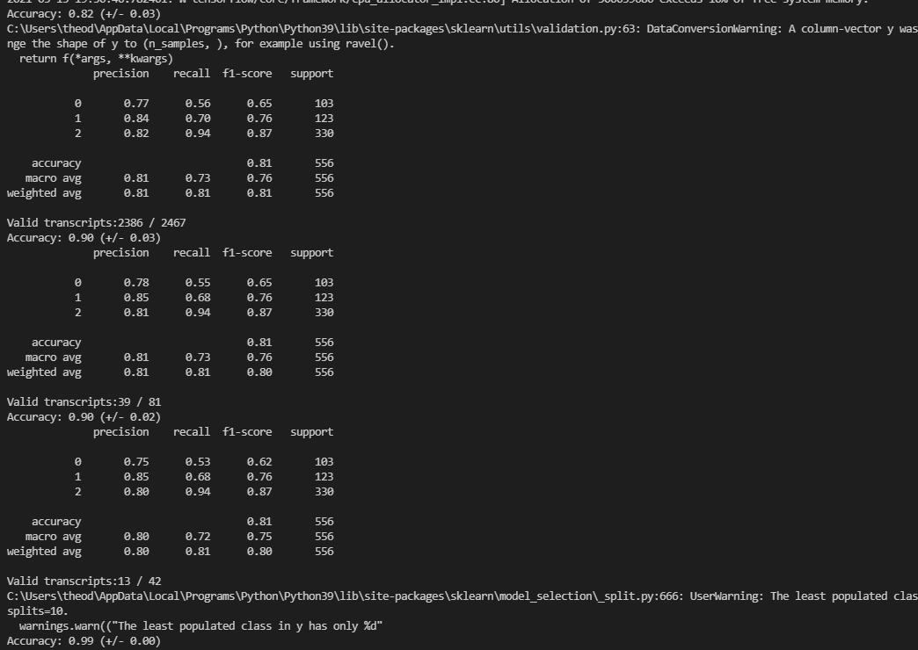
Stanford core nlp preprocessing

